Sports

International restrictions pose a challenge for resuming pro sports

Crossing borders requires 'essential worker' status that leagues don't yet have
Jamie Strashin · CBC Sports · Posted: Apr 29, 2020 10:33 PM ET | Last Updated: 10 hours ago
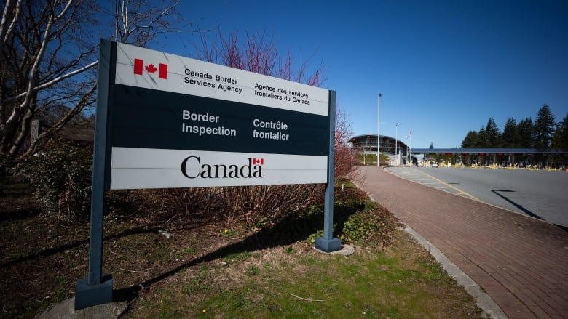
Plans for major sports leagues to resume are complicated by the international border between Canada and the U.S. (Darryl Dyck/Canadian Press)
1
comments
There has recently been lots of hopeful chatter about how and when professional sports will emerge from the Coronavirus lockdown.
The NBA has announced players could soon start practising again. And the NHL and MLB continue to float scenarios that would see its players get back into action.
- NHL looking at multi-city return plan among many options for possible resumption
- MLB could resume by July 4 with minimum 80-game schedule: report
All of these plans must confront serious health and logistical hurdles. For Canadian teams, there are additional barriers that will need to be overcome.
Take the NBA's plan to allow its teams to start opening their practice facilities on May 8th, albeit under very restrictive conditions.
That would be especially challenging for the world champion Toronto Raptors. During this prolonged shutdown, many of its players have returned home to the United States.
With Canada-U.S. currently restricting all non-essential travel across the border, would those members of the Raptors be permitted to return to Toronto to resume practice?
A number of concessions would have to be made.

Is traveller's trip essential?
"All travel of an optional or discretionary nature, including tourism and recreation, are covered by these measures," Canada Border Services Agency spokesperson Judith Gadbois St-Cyr told CBC Sports.
"It comes down to whether the purpose of a traveller's trip is essential or not. If the reason they are seeking entry is not considered essential under the current restrictions, they would not be allowed to enter Canada."
At this point in time, there has been no determination as to whether athletes or professional sport would be considered essential.
"I would not speculate on future decisions or changes as this situation remains fluid," Gadbois St-Cyr added.
WATCH | Gary Bettman on possibility of NHL's return:
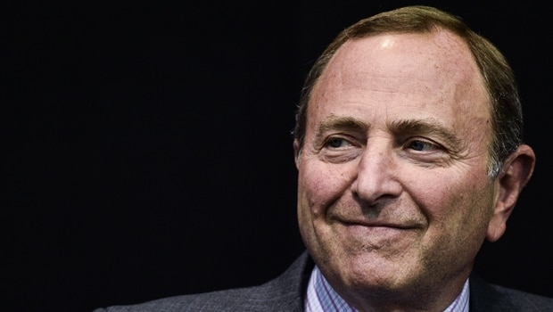
Watch

3 takeaways from the Gary Bettman interview
- 7 days ago

- 2:14

NHL Commissioner Gary Bettman spoke to Ron MacLean about how the league could possibly resume play, Rob Pizzo breaks down the interview. 2:14
Toronto immigration lawyer Sergio Karas says under the current rules, it would be very difficult for professional athletes and teams to make the case that they are an essential service.
"I would say that the governments of both the United States and Canada would have to come up with a joint plan to allow the restrictions to either begin to be lifted or carve out more exceptions slowly. One of those exceptions would be professional sports," Karas said.
Karas said leagues would likely have assurances from officials on both sides of the border that player movement would be allowed before moving forward with any plan.
"The sports leagues in North America are extremely sophisticated and extremely powerful. They have a very large voice," Karas said. "They're not going to do anything without having something firmly in place."
Karas said it's also likely leagues will need to find a way around current rules that require anybody travelling from the United States into Canada to self-isolate for 14 days. As Karas points out, such a rule would make competition nearly impossible.
There would have to be a deal that would have to be an exemption created for sport.- Sergio Karas, immigration lawyer
"There would have to be a deal that would have to be an exemption created for sport," he said. "If they are trying to come from Europe, that's a different issue. They can still come. There is a way for them to obtain special permission."
Beyond travel issues, there are local health and safety regulations to overcome as well. In Ontario, a provincial emergency order that runs at least until May 6 prohibits gatherings of more than five people. The NBA is hoping some teams can re-open facilities on May 8. The Raptors referred CBC Sports to a list of safety measures outlined by the NBA that would have to be in place before any players return to a team's practice facility.
"We intend to be fully in compliance with local, provincial and federal orders and we will follow all public health guidelines with regards to gatherings and travel. The safety of our communities, staff, and players is our highest priority," Raptors spokesperson Jennifer Quinn said.
In a memo circulated to teams this week, the NBA outlined a lengthy list of safeguards including:
- No more than four players permitted at a facility at one time
- Coaches and players remaining 12 feet apart
- Only one player per basket allowed (two players cannot shoot on the same basket).
"Obviously the paramount concern continues to be, as it always has been, about everyone's health including that of the Toronto Raptors themselves and we will sort out with the province whatever seems best in terms of allowing that kind of very limited activity to happen at the practice centre," Toronto Mayor John Tory told a local television station this week.
These measures appear to comply with current provincial regulations.
But officials were non-committal on whether the Raptors would be able to return to their practice facility on May 8th, even in a limited capacity.
"We will continue to provide sector stakeholders and the public updates as the situation evolves based on the advice of Ontario's Chief Medical Officer of Health, and other experts including our federal and municipal partners," a spokesperson for the province's Minister of Heritage, Sport and Culture Lisa MacLeod told CBC.
"We look forward to returning to Ontario's fields, rinks and courts when it is safe to do so."
Beyond practice, what fans really desire (if the through-the-roof ratings for the recent NFL draft are any indication) is a return to games or anything resembling live sport competition, even if it happens in empty stadiums. Any plan that would allow that would require almost constant testing of players and support staff.
WATCH | Sports plans return without fans:
Watch

Can sports really come back with these wacky ideas?
- 22 days ago

- 2:31

Ever since Donald Trump talked to a handful of sports commissioners, plans seem to be leaking about possible return scenarios. Rob Pizzo looks at a few. 2:31
And that could present further issues. Both the NBA and the NHL have already faced scrutiny when seemingly healthy players received tests when members of the general public couldn't get access to them.
In Ontario, the province has been criticized for its inability to implement more widespread testing. It has recently ramped up efforts and is now testing more than 10,000 people a day, with a goal of 14,000 by the end of the month.
"Professional sport could have a contract with a pharmaceutical company that manufactures these tests and makes them available," said Paul Melia, president of the Canadian Centre for Ethics in Sport.
Melia said it would be acceptable if testing for professional athletes didn't divert from the ability of the public health system to develop and deliver tests.
"For a professional sports franchise or the sport itself to have a contract with a test provider that doesn't negatively impact our ability to meet our public health needs. I don't see a problem with it."
In Germany, where the Bundesliga soccer league has targeted a May return for games without spectators, a massive amount of testing would be required. Officials say it will cost about $3 million dollars Cdn to administer 25,000 coronavirus tests on a weekly basis to the league's 1,100 players.
"There is a huge appetite for sport to return at all levels and in all forms. At the same time, the priority has to be our public health authorities at the provincial level and at the local level having sufficient tests to do the testing they feel they need to do to phase us back to work in the province of Ontario," Melia said.
"If that isn't compromised in any way shape or form by professional sport doing the things they need to do to get up and running I think people would probably be comfortable with that."

ABOUT THE AUTHOR
Jamie Strashin
Reporter
Jamie Strashin is a native Torontonian whose latest stop is the CBC Sports department. Before, he spent 15 years covering everything from city hall to courts and breaking news as a reporter for CBC News. He has also worked in Brandon, Man., and Calgary. Follow him on Twitter @StrashinCBC

